
Python Task -2

Use Jupiter Notebook to execute following code, try to guess what is happing in this code.
1. Write down above code using vim on same working directory, and execute it using python interpreter, tell us difference between Jupiter and notepad.
Ans: -in Jupiter NumPy and matplotlib already installed but in notepad we have to install this liberary. 2. Write Down difference between interpreter and compiler.
Ans: -

Interpreter
Translates program one statement at a time.

Interpreters usually take less amount of time to analyse the source code. However, the overall execution time is comparatively slower than compilers.

No Object Code is generated, hence are memory efficient.

Programming languages like JavaScript, Python, Ruby use interpreters.
Compiler

Scans the entire program and translates it as a whole into machine code.

Compilers usually take a large amount of time to analyze the source code. However, the overall execution time is comparatively faster than interpreters.

Generates Object Code which further requires linking, hence requires more memory.

Programming languages like C, C++, Java use compilers.

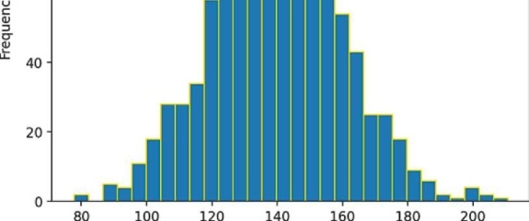
3. What is Data Structure, why do we need one in programs?
-
Ans: - Data structure is a way of organizing and storing data in a computer so that it can be accessed and updated. efficiently. It is not only used for organizing the data but also for processing, retrieving, and storing data. Data structures provide a way to organize and store data in a way that allows for efficient retrieval, manipulation, and storage of data. The main function of the program is to store and retrieve the user's data as fast as possible. Data structures play an important role in enhancing the performance of a program. They are known to be major factors for collection, storing and organizing of data rather than algorithms in some programming languages.

4. Run all python (.py) files inside day2 folder on drive, try understanding code beneath each script, you will going to create those scripts by yourself in future lecture
[2]: i unp»y M up fj»j ^ ^ t^J ? t
iicpor-t natplotlib.pyplot as pit height = np. r«n^0«».non»ial(l4^# 20, 1000) pi t.figure (dpia2&0) plt.tltle(*Height Distributer*) pit.xlabel("Height (cn)") pit.yldbel("Frepuerey*) plt.hist(haight, binsiSd, ac«*gold“) pit.show()

Height Distribuion 100 -\

80

>, 60-

Height (cm)

Ans:-

